**San Francisco Bay University**

**MATH201 - Calculus-I**

**Homework Assignment #6**

**Due day: 12/7/2024**

**Instruction:**

1. **Push the answer sheet to GitHub in word file**
2. **Overdue homework submission could not be accepted.**
3. **Takes academic honesty and integrity seriously (Zero Tolerance of Cheating & Plagiarism)**
4. Find the following definite integral values

Answer:

c.

d.

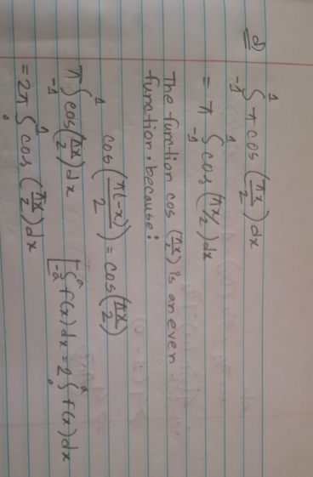

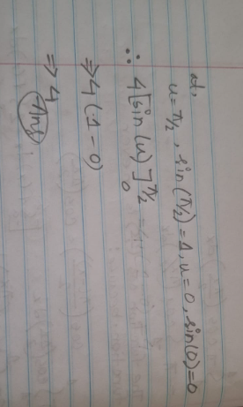

1. Find the following in definite integral function

1. The elevation of a path is given by , where *x* measures horizontal distance. Draw a graph of the elevation function in Excel and find its average value, for .

The graph of the elevation function f(x)= + 30 over the range 0≤x≤4 has been plotted. The average value of the function over this interval is approximately **19.36**.